Ephemeral vs. App State

Objective:
Learn the differences between ephemeral (local) state and app state in Flutter, and how to manage them effectively in a Flutter application.
Materials Needed:
- A computer with Flutter installed.
- A code editor (like VS Code or Android Studio).
- The provider package installed in your Flutter project.
Steps:
- Introduction:
  - Briefly discuss what state management is in Flutter.
  - Explain the difference between ephemeral state and app state:
    - Ephemeral State: Short-lived state that only affects a specific widget or part of the UI. Example: a counter value that resets when the widget is rebuilt.
    - App State: Long-lived state that affects the entire app or large portions of the UI. Example: theme preferences (dark/light mode) that persist across different screens.
- Setup the Project:
  - Inside the surname_advmobprogAY2627 create a new Flutter project using the command: flutter create surname_advmobprog.
  - Open the project in your preferred code editor.
- Implement Ephemeral State:
  - In lib/main.dart, create a simple counter app that uses setState to manage the counter value.
  - Code snippet:
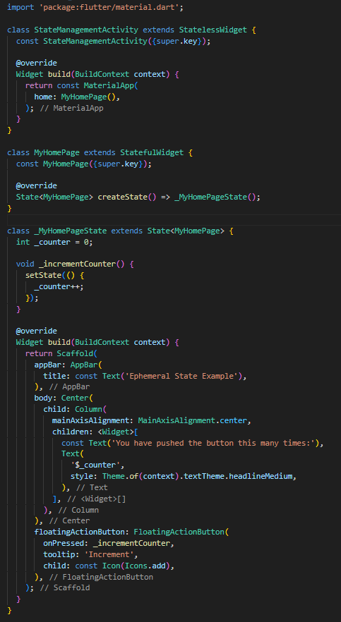
  - Run the app and observe how the counter behaves.
- Implement App State:
  - Add the provider package to your pubspec.yaml file and run flutter pub get.
  - Modify the project to manage theme switching (dark/light mode) across the entire app using Provider.
  - Code Snippet:
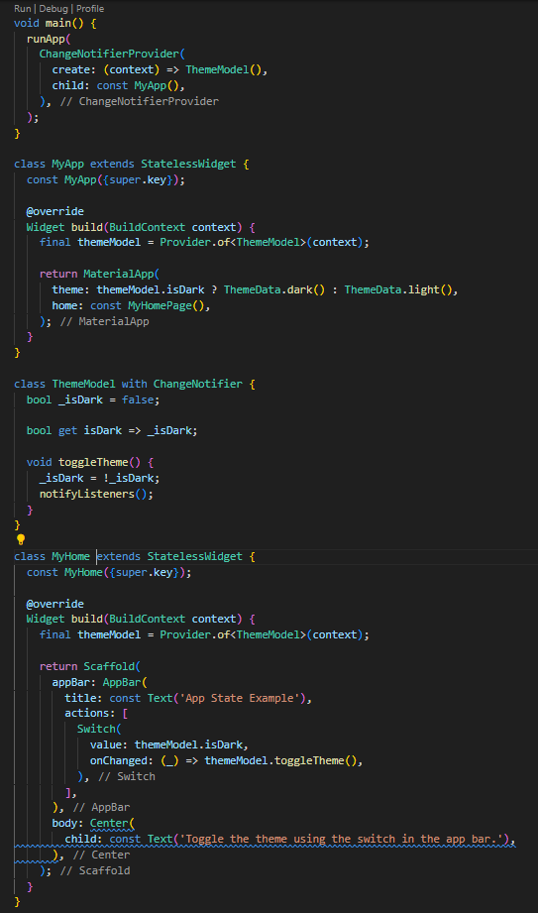
- Hands-on Activity:
  - Modify the app by combining both ephemeral and app state:
  - Use the counter from the first part but allow the user to toggle between light and dark themes using the switch.
- Discussion:
  - Discuss the differences between using setState and Provider.
  - Add comments for each function and class on what is the purpose or use of it.
Activity Rubrics

Criteria | Excellent (4 pts) | Good (3 pts) | Fair (2 pts) | Poor (1 pt) | Points
Logic & Code Implementation | Program runs flawlessly with optimal logic flow; all features (placeholders, avatars, widgets for like/comment) are correctly implemented and error-free. | Logic is mostly correct, minor flaws present, or one minor feature missing. | Logic contains noticeable flaws or inefficiencies; two or more features missing. | Code has major logic errors, does not run, or is significantly incomplete.
Design Accuracy & Consistency | UI matches intended design precisely with proper spacing, alignment, colors, and styles; highly consistent across all components. | Design mostly matches with only minor spacing, alignment, or style issues. | Design deviates noticeably from intended layout; inconsistent styling or incomplete visual elements. | Design is unrecognizable, lacks consistency, or ignores provided specifications.
Widget Usage & Interactive Elements | Widgets (placeholders, avatars, like/comment buttons) are implemented effectively, enhancing functionality and interactivity. | Most widgets are used correctly with minor implementation or interaction issues. | Widgets are inconsistently used, or two or more interactive features are missing. | Widgets are not implemented, or interactivity is absent.
Code Structure & Readability | Code is well-structured, modular, and follows best practices; easy to read, maintain, and extend. | Code is mostly organized with minor structural issues or small readability problems. | Code has structural weaknesses or poor formatting that affects readability. | Code is disorganized, hard to read, and does not follow any clear structure.
 | Other Comments/ Observations: |  |  | Total Score
 |  |  |  | Rating: (Total Score/16) * 100

